Bioc 404 – Biophysical Chemistry
March 24th, 2006
Benoit Lamairesse

X-Ray Crystallography:
(Dr. Cygler)

Lecture 1

Dr. Cygler begins the class with a brief introduction to X-ray crystallography, its capabilities, its results, and compares this experimental method with other forms of structure determination.

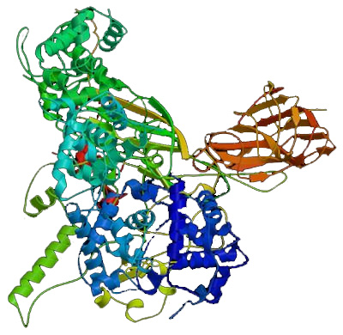
The figure the right is an example of a protein structure similar to that which Dr Cygler showed us at the start of class. This is the end product of structure determination, based on the alpha-C atoms of all the molecules. The protein is colored from blue (N-terminus) to red (C-terminus).

An X-Ray Crystallography experiment yields a structure as a final result. From this structure, one can determine a number of things:
- binding sites
- transmembrane domains
- catalytic domains
From these we can learn why proteins are so good at what they do… We can learn why an enzyme is so much more efficient than the best chemical catalysts we are able to synthesize in a lab.

Once a structure is determined, however – that’s not the end of the story. Studying a macromolecular structure is much more than determining what the structure is. Dr. Cygler uses the following analogy to explain structural determination studies:

Once a protein’s structure is determined, it’s like having a roadmap. One knows what the territory looks like, but we only have a vague idea of what actually goes on down there. Studying the structure of a protein is like getting in a car and traveling the path to see what actually happens at all the crossroads.

We need to be aware that a structure is like a snapshot – one steady moment in a whole reaction pathway. A protein can change shapes, move around, bind to things, interact with the solvent... for this reason a structure may not be the most accurate depiction of a protein in solution.
Dr. Cylger provides us with a few resources that may help us better understand the material:

Books:
- C. Branden & J. Tooze, Introduction to Protein Structure
Is more of an introduction to protein structure with a little bit on X-ray Crystallography…

- J. Glusker& K. Trueblood, Crystal Structure Analysis &
- G. Rhodes, Crystallography Made Crystal Clear
Are easy explanations of the concepts involved, with the former being the easiest.

- J. Drenth, Principles of Protein Crystallography
Is a link which focuses primarily on the math side of X-Ray Crystallography.

Databases:
- http://www.rcsb.org/pdb/Welcome.do
The RCSB database is a database which contains the coordinate sets for all known 3-D protein structures… some 30,000 sets.

- http://scop.mrc-lmb.cam.ac.uk/scop/
- http://www.biochem.ucl.ac.uk/bsm/cath/cath.html
Scop and Biochem are both derived from RCSC, however they present an analysis of the coordinate sets in the RCSC database. They present similarities and differences between structures, classifying them into families, superfamilies, and eventually clans of proteins.

Web Courses:
- http://www.bioinfo.rpi.edu/~bystrc/courses/bcbp4870.html
- http://www-structmed.cimr.cam.ac.uk/Course/

Now we get down to comparing X-ray crystallography to other methods of structure determination…

X-ray diffraction provides us with a resolution of ~0.8-3.0 angstroms. (An angstrom being 10⁻¹⁰ m).To put this in perspective, we note that the length of a C-C bond is approximately 1.5 angstroms, and that a typical atom’s size is therefore in the range of 1-1.5 angstroms. Since x-ray diffraction provides us with a resolution down to ~0.8 angstroms, it provides us with atomic resolution.

Nuclear Magnetic Resonance (NMR) is a method that we should all be familiar with by now. It provides us with a resolution of ~2.5 angstroms. However – this method is based on taking the distance between atoms, and deriving the structure by calculations. This means that you may end up with a host of possible structures, and are left with picking and choosing the “true” one. Furthermore, as we’ve seen in Kalle’s lectures, depending on the region we are observing, some regions (ie. Those towards the interior of the protein) are very well defined, and others (ie. Terminal ends on the exterior of the protein) are not well defined at all.

Electron Microscopy provides us with a resolution of ~3-15 angstroms, though it’s generally more along the lines of 10-15 angstroms. Essentially you shoot high energy electrons into a sample and see how they come out. Dr. Cygler tells us that this field is presently undergoing enormous growth, with new instrumentation and improved methods of sample preparation. This field allows us to observe larger and larger molecular structures, to the point of observing molecular complexes. Electron Microscopy is very advantageous also because it doesn’t require nearly as great a quantity of sample as x-ray diffraction, and avoids the crucial step of the crystallization of the sample, which is the most difficult part of x-ray diffraction experiments. Combining this method with x-ray diffraction experiments allows near-atomic resolution of much larger structures.

Not much was said about Atomic Force Microscopy (AFM), but the basic principles were outlined… This method measures the distance to the surface, and therefore provides you with a topological map of the sample. The typical analogy would be like closing your eyes and feeling your way around a strange room to create a mental picture of your surroundings. The major advantage to this method is that it may be done in solution, however, the resolution by this method is rather poor.

Now… let’s cover the essentials of X-ray crystallography:

X-ray crystallography is based on the diffraction of electromagnetic radiation (hence the interchangeable name x-ray diffraction). Problem is – the electromagnetic spectrum is huge – ranging from the long wavelengths of radiowaves to the high-energy wavelengths of gamma radiation. The X-ray spectrum finds itself between the UV range and the Gamma-ray range: wavelengths between 10⁻⁷ and 10⁻⁹ cm. (Note that 1 angstrom is 10⁻⁸ cm.)

Why x-rays and not gamma rays or UV? Well, for one thing – gamma rays would probably damage your sample and UV would probably only give you fluorescence information, as covered in Galley’s section. In order to properly measure distances, one needs the proper size “measuring stick.” For example – you wouldn’t use a 4-foot pole to measure the length of a piece of paper. You could use that to measure the length of the room, but it’s not practical for things of smaller dimensions:
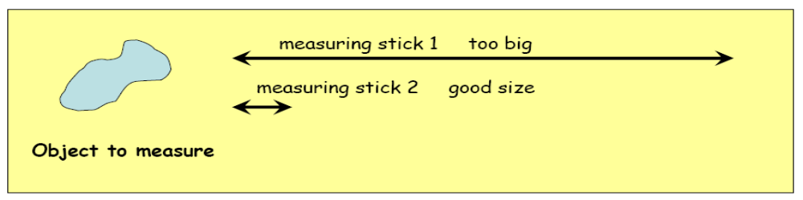
Similarly, you need the proper size of wavelength to measure something on the order of magnitude of a molecular bond. The proper wavelength of radiation is approximately the length of the distance you are trying to measure. (For a resolution of 1 angstrom, your radiation must have a wavelength of approximately 1 angstrom, or 10⁻⁸ cm – the center of the x-ray spectrum.)

On a side note; x-ray diffraction was discovered in 1897/1898 by Wilhelm Röntgen. 15 years later, it was being used to demonstrate that crystals are ordered arrays of atoms.

Now, all of us are familiar with the functioning of a light microscope… A lens of higher optical density refracts (bends) the light, sending it in a different path than that in which it was originally traveling. The rays eventually focus back at a point behind the lens. The refractive index of materials is approximately 1 for very small wavelengths (like X-rays). Because there is no material yet discovered that has an optical density high enough to visibly refract wavelengths of 1 angstrom, the principles of an optical microscope cannot be used to measure structures to atomic resolution.

N.B. - Though the physics behind X-ray diffraction was not discussed, I presume this section on light microscopy was to explain that x-ray crystallography, though based on the reorientation of electromagnetic waves not unlike a light microsope, utilized very different principles from light microscopy to provide us with an image of the sample.

Periodic Function in Time and Space:

Let’s review some basic electromagnetic physics & math:

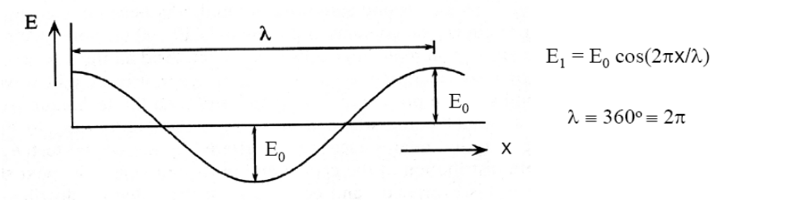An electromagnetic wave is described by a periodic function. Its periodicity is both in space and in time. This means that if we stand still at one point and an electromagnetic wave passes us, the electromagnetic vector with oscillate up and down with time. Since it also oscillates in space, the amplitude of the wave is a periodic function of the distance from the source:

Its motion in both time and space can therefore be described mathematically by the functions sine and cosine (sin & cos). It doesn’t matter which of the two you use, as long as you place your origin accordingly. (ie: if your origin is at the maximum or minimum of the wave, use cosine. On the other hand, if you want to place your origin where the wave crosses its axis of propagation, use sine.)

A wave has a periodicity of 360 degrees (2π radians) per wavelength (λ). This means distance traveled and amplitude are related by the following function:
, (as described in the figure above)

where 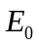 is the amplitude of the wavelength.

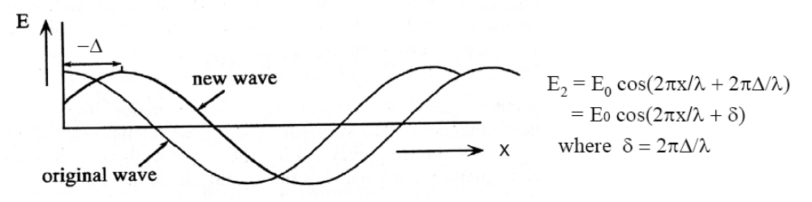If two waves are traveling together, they can be added to each other, a phenomenon called interference. The second wave can be described by the formula:
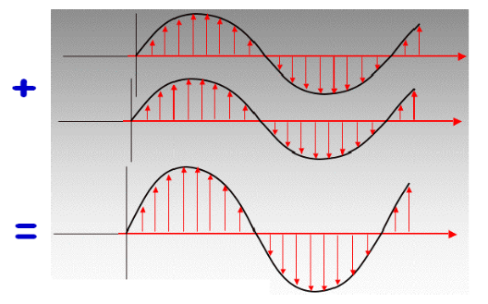Where δ is the phase difference.

If δ = 0 (or any multiple of 2π), the waves are considered in phase, and the effect is additive:

… The resultant wave has an amplitude twice as great as that of either individual wave, a phenomenon known as constructive interference.

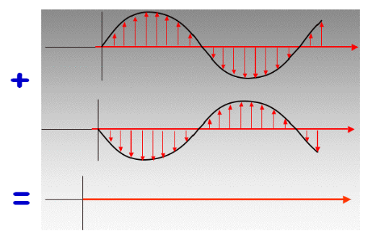

…And if δ = π (or any odd multiple of π), the waves are considered out of phase, resulting in the canceling of the two wavelengths – termed destructive interference.

…Simple, right?

Here’s the problem: superpositioning of two waves is easy: you add the sine and cosine functions of the two waves, get a quick result. Once we start superpositioning multiple waves, it becomes difficult to sum up all of the trigonometric functions. There is therefore another way of describing the behavior of the electromagnetic waves: complex functions.

Complex functions allow us to sum exponents instead of trigometric functions. The reason we use complex functions is simply because it allows us to keep x and y components separate. Don’t be afraid of the i term, it’s there ONLY as a label to separate the term for the y-component from the term for the x-component.

…Bear with me:

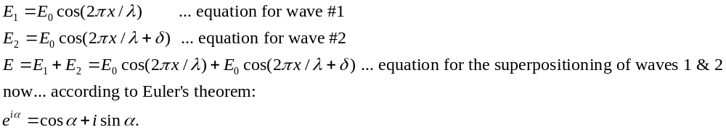

Here’s the proof, just in case you’re not quite sure how that works:
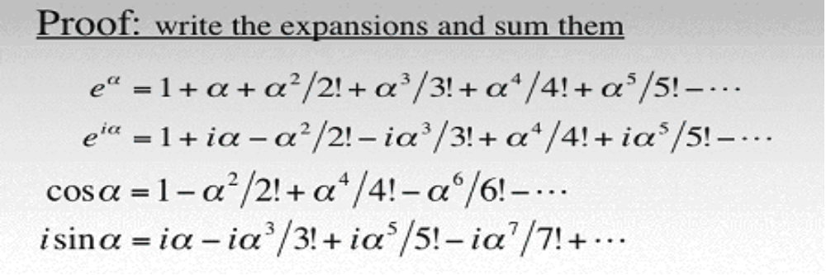

Why is this important? Well – all waves can be described by the sum of a cosine and a sine function:
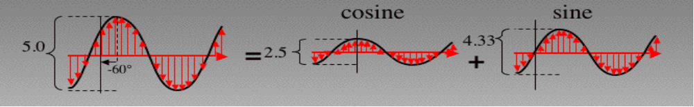
So… let’s describe these two waves in exponent form through the use of Euler’s theorem:

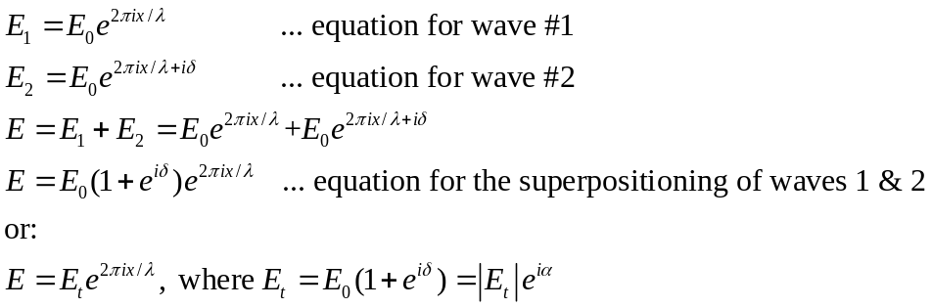

Note: Both α & δ are phases, but they are NOT the same. δ is the phase of wave #2, and α is the phase of the wave resultant from the superpositioning of waves 1 & 2.
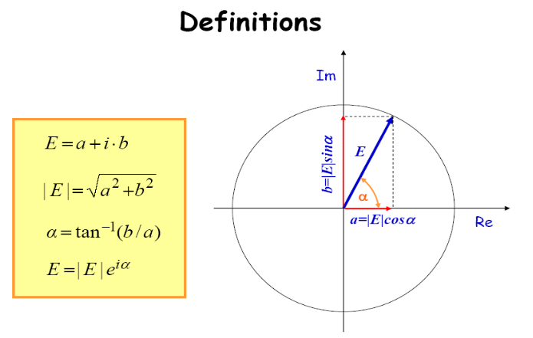
This is what it looks like, when graphed:

Again, note that the i is there solely to separate the x- and y- components. When you calculate the magnitude of the vector using the Pythagorean theorem – you drop the i term.

i.e.:
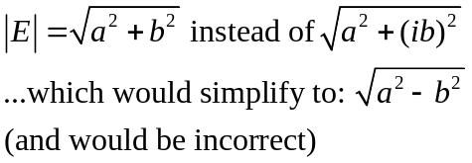

A wave has both magnitude (the modulus of the vector, |E| ) and phase (the angle α).

Here are two examples of wave superpositions where you see:
- the original waves
- the wave resultant from the addition of waves 1 & 2
- the wave converted into a vector projected on imaginary and real axes
- 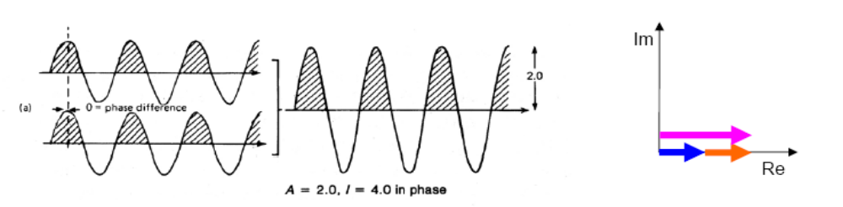α & δ

1) δ = 0
α = 0

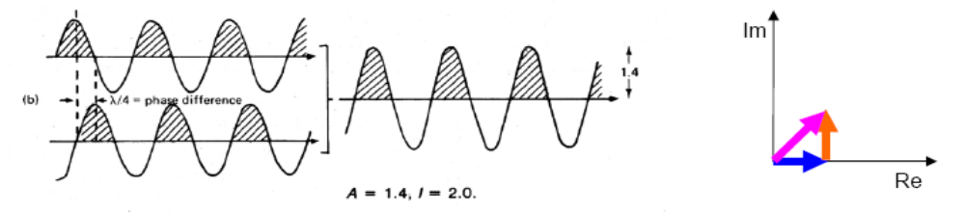
2) δ = π/2
α = π/4

